create table country(

id int,

country_name varchar(50),

country_name_eng varchar(50),

country_code varchar(50)

);

INSERT INTO Country (id, country_name, country_name_eng, country_code)

VALUES

(1, 'Deutschland', 'Germany', 'DEU'),

(2, 'Srbija', 'Serbia', 'SRB'),

(3, 'Hrvatska', 'Croatia', 'HRV'),

(4, 'United States of America', 'United States of America', 'USA'),

(5, 'Polska', 'Poland', 'POL'),

(6, 'España', 'Spain', 'ESP'),

(7, 'Rossiya', 'Russia','RUS');

select * from country;

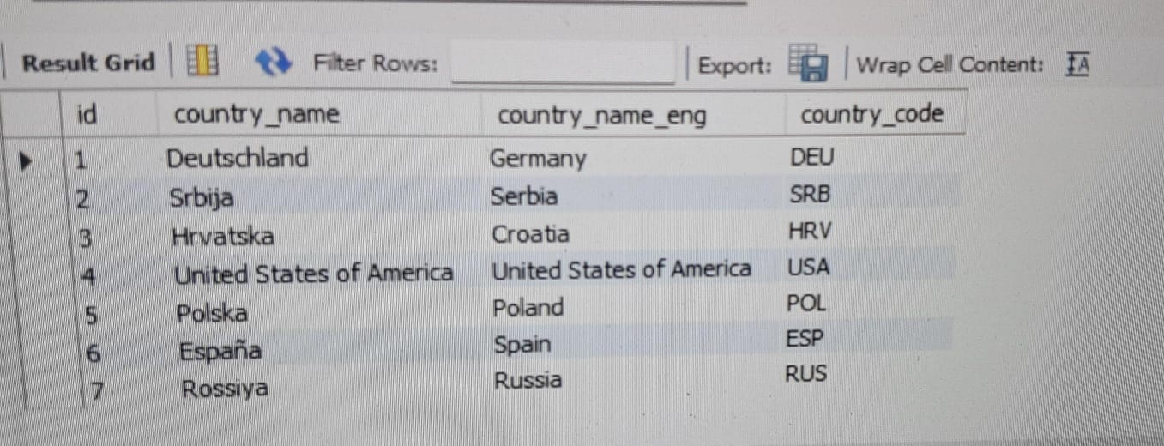

Task: 1 (join multiple tables using left join)

For each country displaying its name in English, the name of the city customer is located in as well as the name of the customer.

select country_name_eng from country;

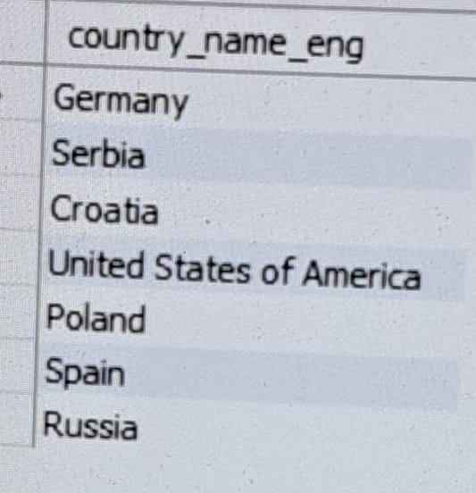

Return even countries without related cities and customers.

SELECT *

FROM customer

WHERE id%2=0;



Task: 2 (join multiple tables using both left and inner join)

Return the list of all countries that have pairs(exclude countries which are not referenced by any city). For such pairs return all customers.